**Info to share with TA prior to Meeting**

Fill out this document prior to meeting with the TA to help guide your conversation. Load the form in Blackboard and the TA will be able to see your form prior to the meeting.

**Group Number:**

**Team Members:**

1. Don Nguyen

2.

3.

1. Question: State your question

Please refer to part (c ) for starting information on the topic of razor promotion.

1. Check for distribution information on all tracked metrics within the database. Are the significant difference among recorded metrics between age groups and between the purchased and the non-purchased?
2. Based on the information in part (a), optimize the promotion strategy by allocating between SMS and email, given the customer pool for next month.
3. Population studied and time frame of interest

Population: 300000 entries of total SMS and email sent.

Time frame of interest: April 2019.

1. Background Information

“We are a data analyst team under Trusting Social SEA, estimating market performance of a new generation of electric man razor. We registered an ecommerce site to sell the product online instead of traditional markets. In April 2019, we advertised on 2 channels: Email and SMS. We have data extracted from centralized database.”

1. Dataset information

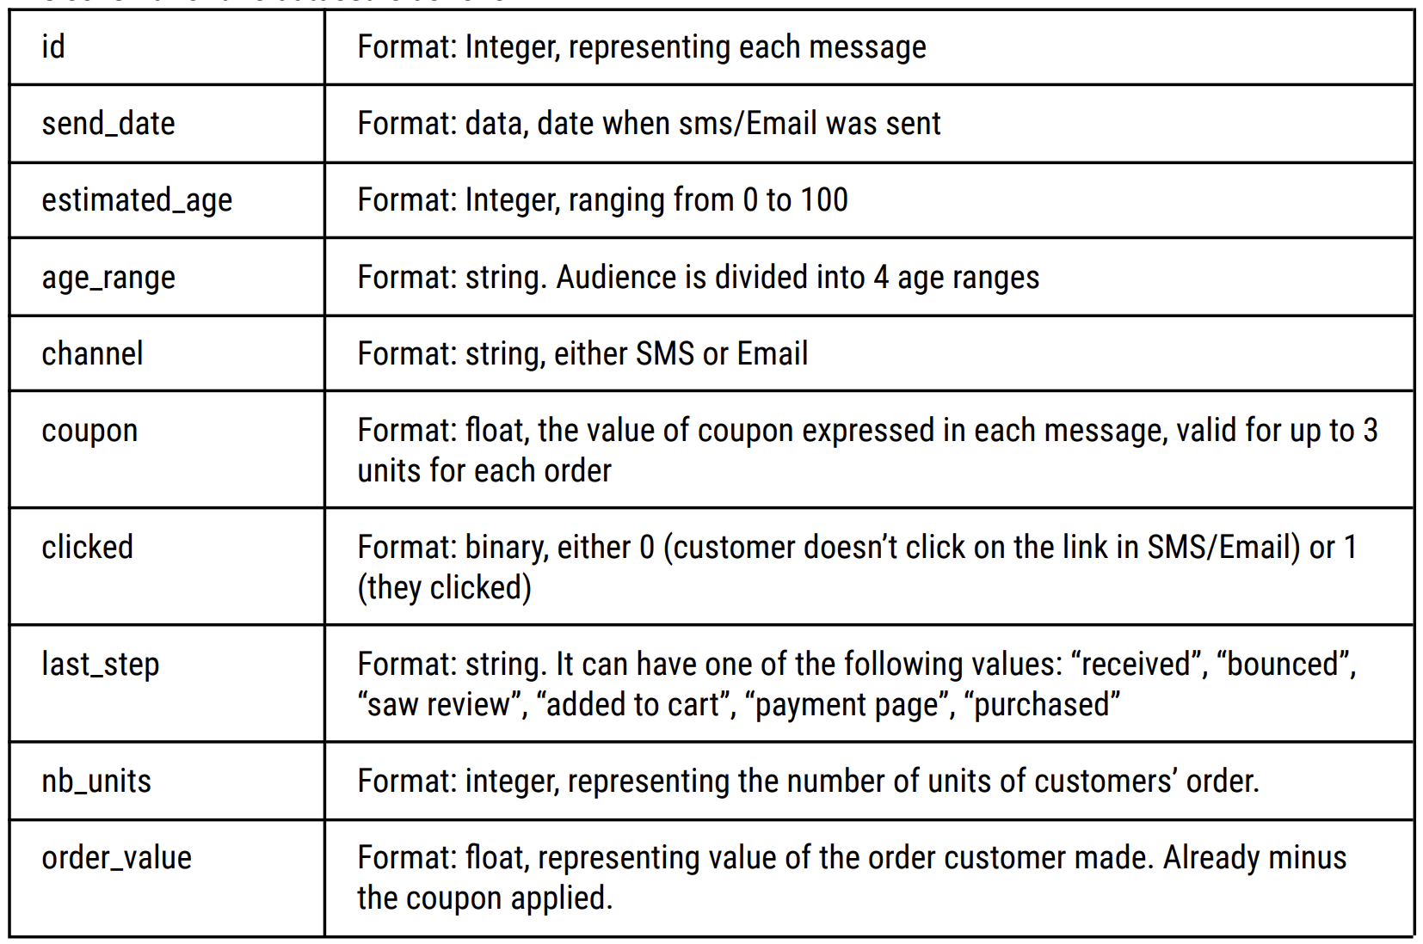

The column ‘last step’ is the point of contact with customers before they leave our website. Its value are explained below:

* Received: sms/email sent but not opened
* Bounced: opened but did not finished 3 survey questions used to activate promotional coupon.
* Saw review: scrolled down and read information on the product
* Added to cart: customer added product to checkout.
* Payment page: checked out but not purchased
* Purchased made an order.

The 3 survey questions to activate a coupon are as follow:

* What is the price of the last razor you purchased (dollars)
* How long do you typically use a razor before replacing it? (in months)
* How satisfied are you with your current shaving experience? (1: Not satisfied, 5: Very satisfied)

Resulting data from the survey is to be collected.

1. Financial information

* Production cost for each razor: $18
* Cost per SMS: $0.05, Cost per email sent: $0.075
* Each email or SMS will be supplied a coupon of value $2/4/6, valid up to 3 razors per order.
* Selling price without coupon: $40

1. Research findings

* Hypothesis: Younger age groups are more responsive to email promotion, while older age groups are more responsive to SMS promotion (1).
* Hypothesis: The price of the previous razor purchase does have an impact on the whether purchase for a new razor will be made (2). Although this may not hold true for the current studied demographic – 2019 South East Asia.

1. Confirmation this question has not been answered: What similar work or analysis has been done with respect to this question or the data set you are using?

This is a closed and archived dataset. No information is found online regarding the source and next step of this dataset.

1. References

(1): <https://advertising.amazon.com/library/guides/generational-marketing>

(2): <https://shavercheck.com/electric-shaving-costs/>

1. Why is this question relevant to study?

The questions proposed help to better target customers based on demographics to minimize advertising cost and maximize profit.

1. Possible Data Sources

Data source can be referred to in (c ).

**Additional comments:**